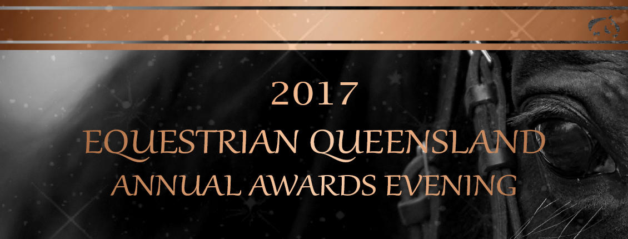

Date: Saturday, 3 February 2018 Venue: Rydges Southbank

Time: 6:30pm for pre-dinner drinks 7:00pm for dinner seating
Dress: Evening attire
Cost: Adults -members $140 Non-Members $160
Children (U/16) $95 Table (X10) $1350
(Please provide one method of payment)
Included: Pre-dinner drinks, Three course dinner;
Drinks - Beer, Wines and Soft Drink*; Dancing to ‘DJ Mr Sparkle’
* Spirits available for purchase on the evening.

AWARD DINNER BOOKING FORM
NB: Confirmation will be emailed on receipt of payment.
Name:
Address:
Phone: |  | Email:

Number of tickets
 |  | Table ($1350 table) (Please provide one method of payment) |  |  | $
 |  | Adult-members ($140 pp) |  |  | $
 |  | Non-Member ($160 pp) |  |  | $
 |  | Child ($95 pp) |  |  | $
 |  | Total Amount Owing: |  |  | $
Payment – please note all cards used will attract a fee of an additional 1.5%
- Please find cheque enclosed (Cheques payable to Equestrian Queensland)
- Please charge my credit card |  |  | Visa Card | MasterCard |  | Amex
Name on Card:

Credit Card Number:

Expiry Date: |  |  | / |  |  | Amount: |  | Signature:

GUEST NAMES

Please Provide the Names of All Guests Included on This Booking,
- Note any Children as (Child) after the name.
- Note any Special Dietary Requirements (ie. Vegetarian) after the name
- Please advise if any seating arrangements are required.

1.
2.
3.
4.
5.
6.
7.
8.
9.
10.
Seating Arrangements
PLEASE RETURN COMPLETED FORM AND PAYMENT
by 4.00pm, Thursday 25 January 2018

By Fax: Complete and fax this form to 07 3891 3088
By Fax: Complete and email this form to manager@equestrianqld.com.au
By Mail: Complete and send with payment to :

Equestrian Queensland,
PO Box 1358,
Coorparoo DC Qld 4151

