Australian Young Rider Dressage Championships

Werribee Park NEC 9-12 April 2015

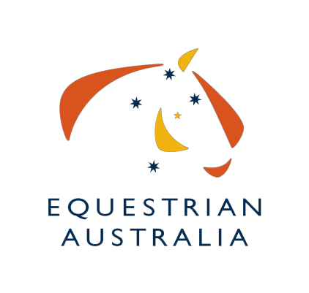


2015 Equestrian Australia National Young Rider Dressage Championships – State Team Competitions

- Team Entry Fee is free

State Teams Nomination Form –
STATE: ________________________________ (indicate below which Team Competitions you are entering)
Note: Where there are insufficient entries to enable a State Team to be entered, the smaller States may combine to enter a mixed team.
Young Rider State Team A – (Horses Only): one each in Novice 2.3, Elementary 3.3, Medium 4.3
Young Rider State Team B – (Horses Only): one each in Advanced 5.3, Prix St Georges or Prix St Georges 22-25, CDI-Y Individual test
Pony State Team A – (Ponies Only): one each in Novice 2.3, Elementary 3.3, Medium 4.3

Contact person:

Tel:
Email:
Name of Chef d’Equipe:

Mob:
Email:

Send nomination form to:

2015 Equestrian Australia National Young Rider Dressage Championships
PO BOX 616
WERRIBEE VIC 3030 or email to dressage@equestrianvictoria.com.au

Signature: _______________________________ Date: _____________________

Reminder: State Team members must be nominated by 17:00 Thursday 9th April 2015 to the OC

