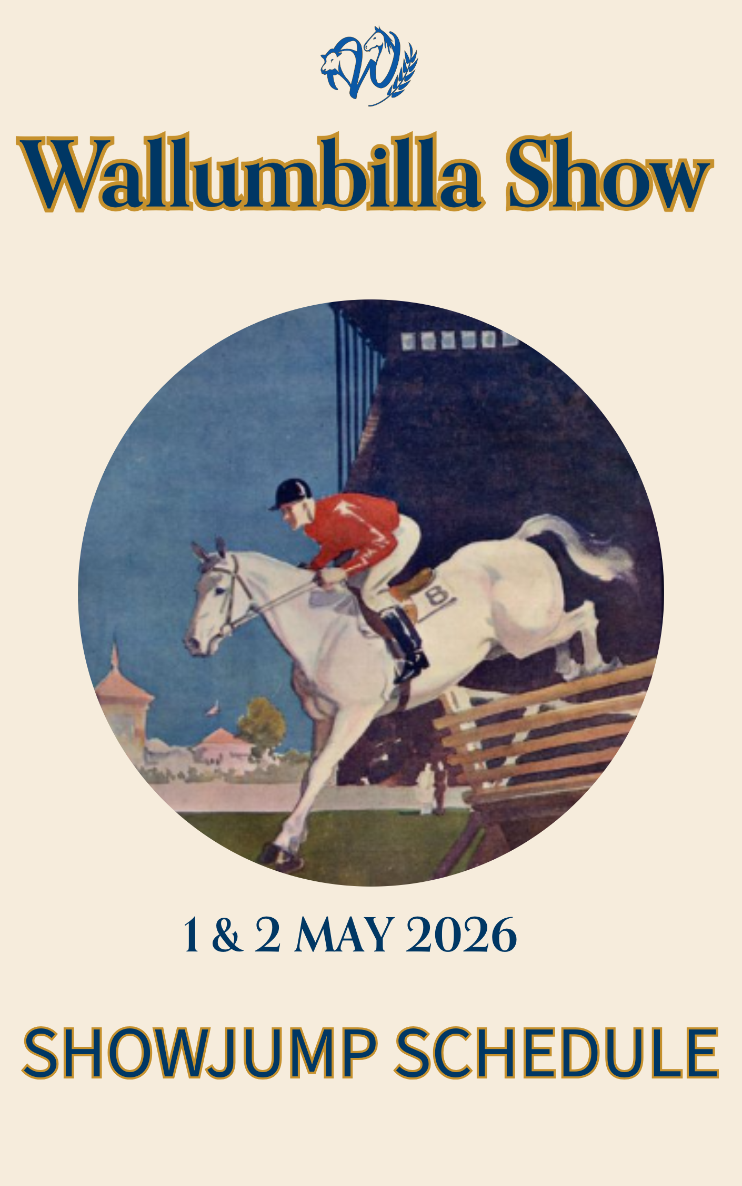

2026 Jump Program
Exhibitors please note!
Wallumbilla Show will be offering a hybrid entry system this year taking both online entries and on the day nominations. We strongly encourage online nominations. Entry to classes will be via presentation of a ticket.

PRE NOMINATE WITH SHOWDAY ONLINE
Showday online streamlines your nomination as you only need register yourself and your horse once to enter multiple events. The system also greatly reduces volunteer workload. Tickets for entries received online will be prepared in advance and be ready to be collected on the morning of the show.
Nominations via ShowDay Online will be open until 7 pm on the day prior to classes commencing
Nominate via https://showday.online/show/wallumbilla

On the day nominations
The horse hut will be accepting nominations between 7 am – 8.30am on Friday & Saturday.
Competitors will need to complete manual nomination forms prior to purchasing tickets. Tickets will need to be manually filled in with the details of the competitor and horse prior to submission at the ring.
It is preferred that nominations be placed via Showday.

Horse Stabling bookings are taken via SHOWDAY ONLINE
Nominate via https://showday.online/show/wallumbilla Horse Stables & Yards
Costs $25 per stable/yard for the duration of the show. Please leave yards clean.
Camping is free.

Conditions of Entry
This event will be run under the Equestrian Australia Show Jumping Rules 2026 EA_FEI Clean_Jumping_Rules_2026 Final_as at 27.01.2026_0.pdf
All competitors are to pay gate entry
All exhibitors are to provide a horse health declaration to the horse hut or secretaries office for all horses on the grounds.
All competitors must wear properly fastened protective helmet whenever mounted in accordance with the above rules.
Registration and membership cards MUST be produced on request.
Entry fees will not be refunded unless entries cancelled more than 7 days prior to the event commencing. There will be no refunds for unused tickets purchased on the day.
Competitors and horses compete at their own risk.
The organising committee accepts no responsibility for loss or injury.
A local means a horse and rider that reside within the Maranoa Shire Council Area.

Thank-you to our Sponsors




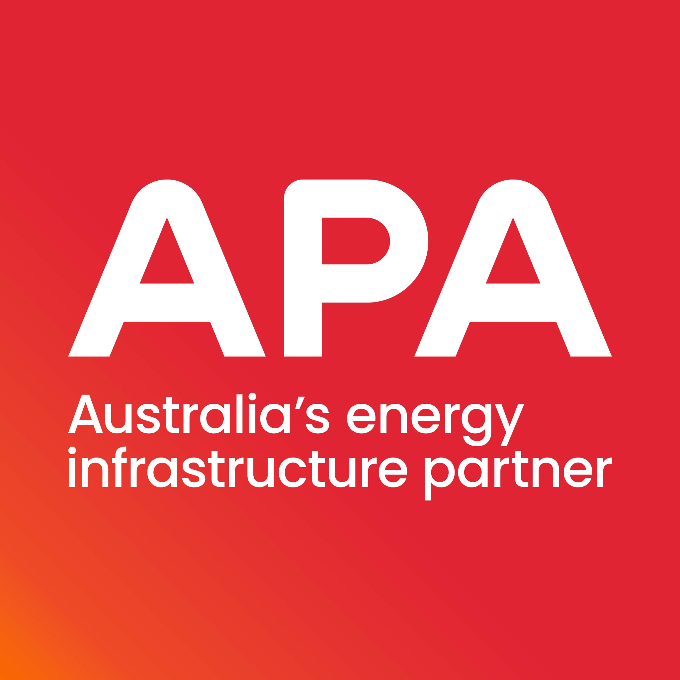

Ring 5 - Start 9.00 am Friday 2ndMay 2025
ENTRY PRIZE MONEY TOTAL
- Under 14 years 60cm Special Two Phase 274.2
$5.00 $30, $20, $10, $5 $65
- Open 60cm Special two phase $7.00 $60, $40, $30, $20 $150
- 70cm Article 238.2.2 $5.00 $40, $30, $20, $10 $100
- 80cm Article 238.2.2 $10.00 $70, $50, $40, $10 $170
- 90cm Article 238.2.2 $10.00 $90, $70, $50, $40 $250
- Off the Track 90cm Spec 274.2 $10.00 $100, $80, $60, $50 $290
- 1m Article 238.2.2 $15.00 $120, $80, $60, $40 $300
- 1.10m Article 238.2.2 $15.00 $140, $100, $60, $40 $340
- 1.20 Article 238.2.2 $20.00 $180, $140, $100, $60 $480

Ring 5 - Start 8.30 am Saturday 3rd May 2025

ENTRY PRIZE MONEY TOTAL

- Off the Track 80cm 274.2 $10.00 $100, $80, $60, $50 $290
- 80cm Article 238.2.2 $10.00 $90, $70, $50, $40 $250
- 90cm Article 238.2.2 $15.00 $140, $100, $60, $40 $340
- 1m Article 238.2.2 $15.00 $150, $120, $60, $40 $370
- 1.10 - 1.20m Article 238.2.2 $20.00 $200, $150, $75, $50 $475
- Local 70 cm Article 238.2.2 $5.00 $15, $10, $5 $30
- Pony Club 13 – 17 Years 238.2.2 $ 5.00 $15, $10, $5 $ 30
(60cm starting height)
- Pony Club under 13 Years 238.2.2 $ 5.00 $15, $10, $5 $ 30
(30 – 40cm starting height)
- Junior 6 bar $10.00 $70, $50, $30, $15 $165
- Open 6 bar $20.00 $175,$125,$100, $60 $460

Off The Track classes are proudly sponsored by Queensland Off The Track Event Sponsorship

