EE

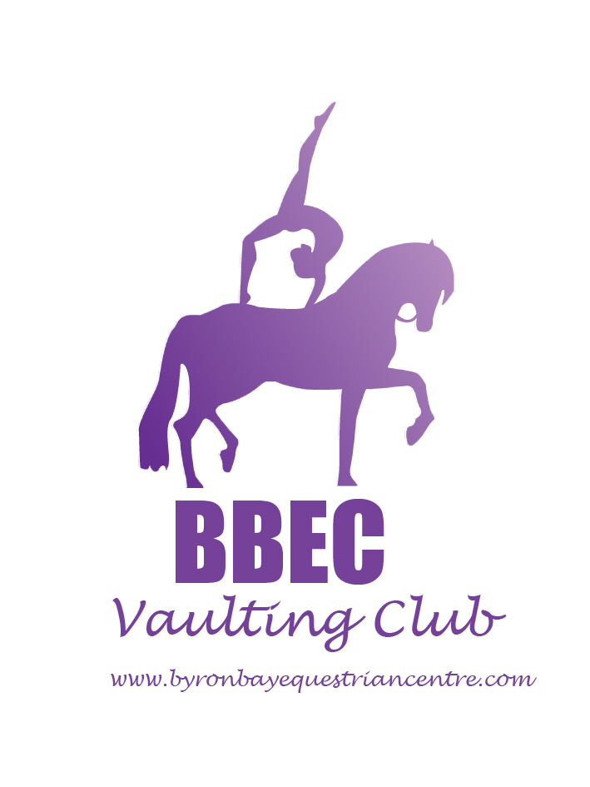
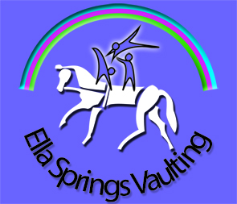
BBEC & ELLA

RIBBON DAY 2017

Organisers: Byron Bay Equestrian Centre
& ELLA Springs Vaulting Club

Sunday 3rd December 2017

Venue: Lot 2 Woodford Lane
Ewingsdale, NSW, 2481
(Drive to the end of Woodford Lane)

ENTRIES CLOSE: 5pm Friday 24th November 2017

ENTRY FEES - $ 35 PER VAULTER FOR UP TO 6 CLASSES

Fees payable to Byron Bay Equestrian Centre by direct deposit:

Byron Bay Equestrian Centre;
BSB 062 578, Account 1026 8184

*Becomes tax invoice upon payment

Enquiries to Tesse Ferguson at manager@byronbayequestriancentre.com or
Call 0410 602 401
- Any entries received after 5pm Fri 24 November will have to be accompanied by a ‘late fee’ of $10 per individual.
- All fees for stabling and camping must be paid with entries.
- Refunds may be considered after the closing date only on presentation of medical and/or veterinary certificate. An administration fee of $10 to be retained by the Byron Bay Equestrian Centre.

Conditions for Classes:

- Vaulters and Lungers must be current members of EA for all Classes or must pay a day membership Levy of $10 per participant.
- Horses must be EA registered for all Competitive Classes
- Any vaulters entered in the ADVANCED class can nominate to participate in the Technical Test Class
- Participant vaulters can combine same level compulsories and freestyle scores to be considered for Annual Participant Awards if eligible (i.e minimum of 3 competitions completed in 2017)

Competitor Classes:

1A | OPEN TECHNICAL TEST | $35
2A | ADVANCED INDIVIDUAL - COMPULSORIES | PER
2B | ADVANCED INDIVIDUAL - FREESTYLE | VAULTER
3A | INTERMEDIATE INDIVIDUAL – COMPULSORIES | FOR
3B | INTERMEDIATE INDIVIDUAL - FREESTYLE | UP
4A | NOVICE INDIVIDUAL – COMPULSORIES | TO
4B | NOVICE INDIVIDUAL - FREESTYLE | 6
5 | OPEN PAS DE DEUX | CLASSES
6 | ADVANCED SQUAD
7 | INTERMEDIATE SQUAD
8 | INTERMEDIATE PAS DE DEUX

Participant Classes:

10A | PRE-NOVICE INDIVIDUAL - COMPULSORIES
10B | PRE-NOVICE INDIVIDUAL - FREESTYLE | $35
11A | PRELIMINARY INDIVIDUAL - COMPULSORIES | PER
11B | PRELIMINARY INDIVIDUAL - FREESTYLE | VAULTER
12 | PRELIMINARY PAS DE DEUX | UP TO
13 | PRELIMINARY SQUAD | 6
14 | AMATURE* INDIVIDUAL PRELIM COMPULSORIES | CLASSES
15 | GREEN HORSE CLASS
* Amature = 35yrs and over

Barrel Classes

16 | INDIVIDUAL BARREL (PRE-NOVICE & BELOW)
17 | PAS DE DEUX BARREL (OPEN/ADV/INT)
18 | PAS DE DEUX BARREL (PRELIM/PRE-NOV/NOV)
19 | BARREL SQUAD (4-6 vaulters) 4 minutes
20 | NOVELTY BARREL (2-3 vaulters) up to 3minutes

Administration
Administration/Judge Levy | $10 Per Vaulter
BBEC Day Membership Levy for non EA Members | $10 Per Vaulter
Prizes: Ribbons to all competitors

Presentation: To be held at conclusion of the day.

NB: Vauting Qld will be presenting the Annual Participant Awards at the conclusion of the Ribbon Day awards on the day.

Athlete with a Disability: Notation of athlete with a disability to be made on the appropriate class on entries.

First Aid: First Aid officer will be in attendance.

Arm Numbers: Clubs to supply their own numbers for squads. Numbers for Individuals will be available for collection at Chef’s meeting.
Practice Time: A practice roster will be prepared, if necessary, after entries have been received.

Assistance required from clubs: It is expected that Clubs will provide helpers to assist with setting up and dismantling, pencillers, time keepers, gear stewarding. Please provide names of helpers & contact details on master entry sheet.

Music: Must be in MP3 format. Music on USB to accompany entries or to be uploaded to Dropbox (Link will be shared with all club managers):

https://www.dropbox.com/sh/v1o1apnm6m8i73m/AADPADtD_75jR4UpYBPLVs1Ea?dl=0

NB: No music will be accepted on the day of the competition

Stabling: There are yards available at $10 per horse or stables at $15 per horse.
Camping: $5 incl power

See “Master Registration” Entry Form below

MASTER LIST OF COMPETITORS

Club:

No | Name | EA No. | Classes entered | Tick AWD
1
2
3
4
5
6
7
8
9
10
11
12
13
14
15
16
17
18
19
20
.

“MASTER” REGISTRATION, Entries
CLUB:

- Summary of Entries | No vaulters | @$35 | $
- Administration/ Judge Levy |  | @ $10
- Day Membership Levy  (required for non EA members) |  | @ $10
- Yards per night per horse  E)Stables per night per horse |  | @ $10  @ $15
- Camping |  | @ $5
Total

Signature of Club Secretary/Coach: _______________________________________________

Contact Phone: ________________________________________________

Email: _______________________________________________

Summary of Entries

CLUB:

Class | No of Entries | $ per
Individual Horse
Individual Barrel
Squad Horse
Squad Barrel
Pas De Deux Horse
Pas De Deux Barrel
Novelty Barrel
TOTAL |  | @ $35 | A

Total number of vaulters entered

INDIVIDUAL ENTRY FORM –Horse

CLUB:

No | Vaulter Name | Horse | Lunger |  | Class
1
2
3
4
5
6
7
8
9
10
11
12
13
14
15

SQUAD ENTRY FORM - Horse

CLUB:

Vaulter Name |  | Team Name | Horse | Lunger |  | Class | $
1
2
3
4
5
6
R
1
2
3
4
5
6
R
 |  |  |  |  | TOTAL

SQUAD ENTRY FORM – Barrel

CLUB:

Vaulter Name |  | Team Name
1
2
3
4
5
6
R
1
2
3
4
5
6
R
 |  | TOTAL

PAS DE DEUX ENTRY FORM- Horse

CLUB:

Vaulter Name |  | Club | Horse | Lunger | Class
1
2
1
2
1
2
1
2
1
2
1
2
1
2
1
2
1
2

INDIVIDUAL ENTRY FORM – Barrel

CLUB:

No | Vaulter Name | Club |  | Class
1
2
3
4
5
6
7
8
9
10
11
12
13
14
15
16
17
18

PAS DE DEUX ENTRY FORM Barrel

CLUB:

Vaulter Name |  | Club |  | Class
1
2
1
2
1
2
1
2
1
2
1
2
1
2
1
2
1
2

NOVELTY ENTRY FORM – Barrel

CLUB:

Vaulter Name |  |  | Team Name
1
2
3
1
2
3
Vaulter Name |  | Team Name
1
2
3
1
2
3

