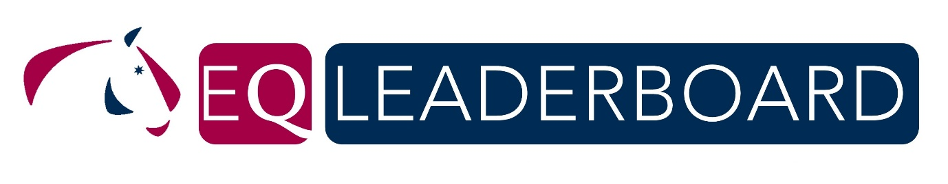

Congratulations and thank you for participating in the 2018 EQ Leaderboard. Please complete these three questions and send to support@equestrianqld.com.au.

*1. The Equestrian Queensland (EQ) was developed to encourage participation of grassroots level riders and to increase support of participant level classes and EQ Affiliated Clubs in the disciplines of Dressage, Jumping & Eventing.
Do you acknowledge and have you read the EQ Leaderboard Criteria & Eligibility and do you agree that you are eligible for the 2018 EQ Leaderboard?
EQ LEADERBOARD CRITERIA & ELIGIBILITY INFORMATION
Yes
No

*2. Please confirm your details for the 2018 EQ Leaderboard -
Rider Name:
Horse/s Name:
Email:

Interclub Challenge:
To recognise the club that has had club members participating across all disciplines in the EQ Leaderboard (the 4 highest scoring club members across the different disciplines will form the team, with the 3 best scores to count. The 4th scores will only be used in the event of a tie). Prize: Club trophy & rosettes for team members.

*3. Please nominate a Club, that you are a member of for the EQ Leaderboard ~ Interclub Challenge. (If you are a member of numerous Clubs you may only nominate one per discipline).
Club (please write NA if not a club member):
Discipline:
Other if riding in more than one discipline:
Discipline:

