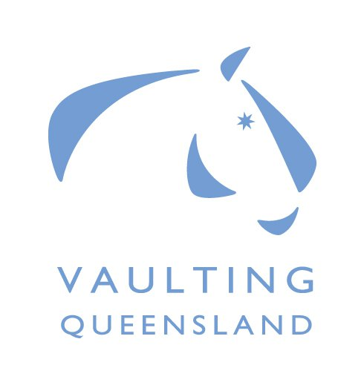
Vaulting Queensland
Development Clinic
December 2, 2017
For Trainee Judges, Officials & Lungers
Presented by
Tristyn Lowe (EA/NCAS Level 2 Vaulting Coach/Level 3 Vaulting Judge)
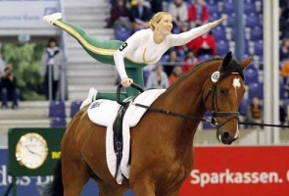

Cost is Free [subsidised by Equestrian Qld Grant]
Location:
Byron Bay Equestrian Centre BBEC
Lot 2 Woodford Lane
Ewingsdale NSW 2481. (Old Pacific Highway)
Ribbon Day competition to be held at BBEC on
Sunday December 3, 2017. Further details to be provided.

Please email your registration details to Darani Cumming dbamc@ozemail.com.au by COB 20/10/17.

Name: Click or tap here to enter text.
Email: Click or tap here to enter text.
Mobile: Click or tap here to enter text.
Judging: Y☐N☐ Scoring: Y☐N☐ Pencilling: Y☐N☐ Lunging: Y☐N☐ Observer: Y☐N☐
EQ Member: Y☐N☐ if Yes Member # Click or tap here to enter text.

